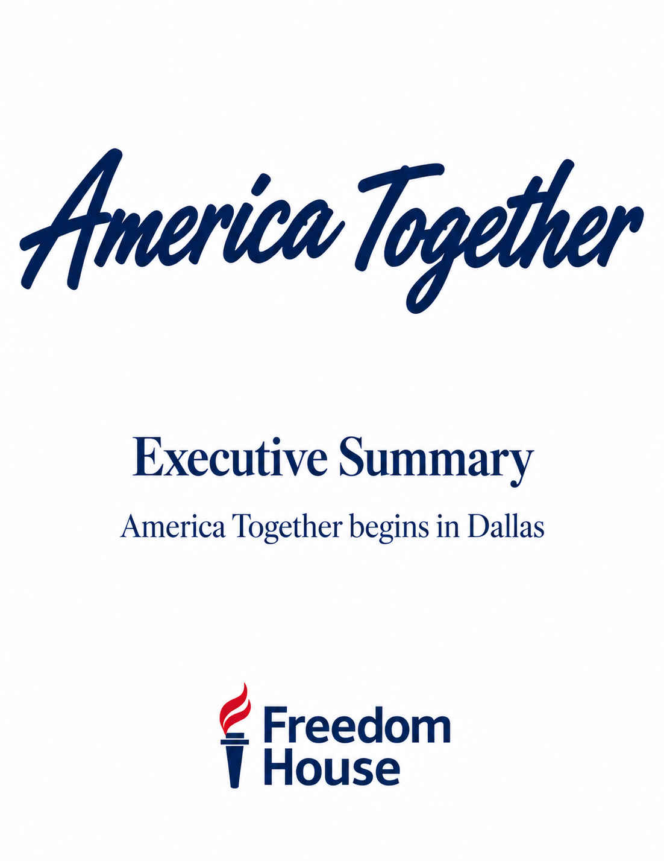

America Together begins in Dallas
America Together is a proposed four-day celebration of freedom and democracy, beginning in Dallas and inspired by the purpose and work of Freedom House.
Through art, music, food and public conversation, America Together invites Americans to gather around the values they share, speak honestly about the issues that divide them and consider the responsibility each generation carries for protecting freedom and democracy.
Dallas is envisioned as the flagship city. The experience would begin several weeks before the formal program, with red, white and blue Kitchen Tables, posters, table cards and QR invitations appearing in cultural venues and gathering places throughout the city. These invitations would introduce Freedom House’s mission, encourage participation and connect people to the four-day celebration.

Four connected experiences
Day One opens with Laura Roosevelt’s Historic American Pop and Norton Wisdom’s NO WAR, using visual art to explore American history, freedom, conflict and civic responsibility.
Day Two moves into music as an expression of freedom and shared culture.
Day Three brings people together through The American Table, a communal culinary experience celebrating chefs, regional traditions and conversation.
Day Four culminates with Let’s Talk America, a Kitchen Table Conversation where the ideas, people and experiences of the preceding days come together.
The Dallas finale is intended to become the defining moment of America Together. Its opening conversation would bring together journalists, civic leaders, cultural voices, educators, veterans, democracy advocates, former public officials, students and members of the Dallas community to explore the common values and responsibilities that connect Americans.
Following an intermission featuring chefs and culinary partners from The American Table, our ambition is to close the program with filmmaker Ken Burns leading a conversation with former Presidents George W. Bush and Barack Obama. Advancing the introductions and invitations needed to secure their participation is a major priority. All proposed participants remain subject to invitation, confirmation, scheduling, security and approval.

Freedom House and the purpose behind the celebration
Freedom House is central to the vision. America Together is intended to broaden awareness of its work defending freedom and democracy and generate meaningful financial support for that mission.
The proposed relationship would define America Together’s responsibilities as producer and Freedom House’s role in the program, fundraising and public communications. That framework is being developed for legal review and Freedom House’s consideration and approval.

The proposed funding model
Our goal is to secure corporate sponsorships, philanthropic support and program underwriting sufficient to cover the full cost of the Dallas presentation. With production costs covered, net proceeds from ticket sales and merchandise, together with designated contributions, would provide financial support for Freedom House.
The working budgets and sponsorship opportunities are found in the Sponsorship and Production Plan sections of this package. These materials will be refined as costs are confirmed and the financial arrangements are reviewed with counsel and Freedom House.

From Dallas to a national series
Dallas would establish the foundation for a proposed series of 8–14 total presentations, including Dallas. Production Plan 1 addresses the opening event. Production Plan 2 sets out the continuation after Dallas, including the continuing team, staffing estimates and travel framework.
The immediate work is to turn the concept into commitments: advance participant conversations, develop sponsorship support, confirm venues and production requirements, and establish the agreements needed to proceed.
America Together is designed to do more than produce a successful event. Its purpose is to make freedom and democracy visible through shared experiences, expand awareness and support for Freedom House, and demonstrate that Americans can engage across their differences without surrendering their convictions.

