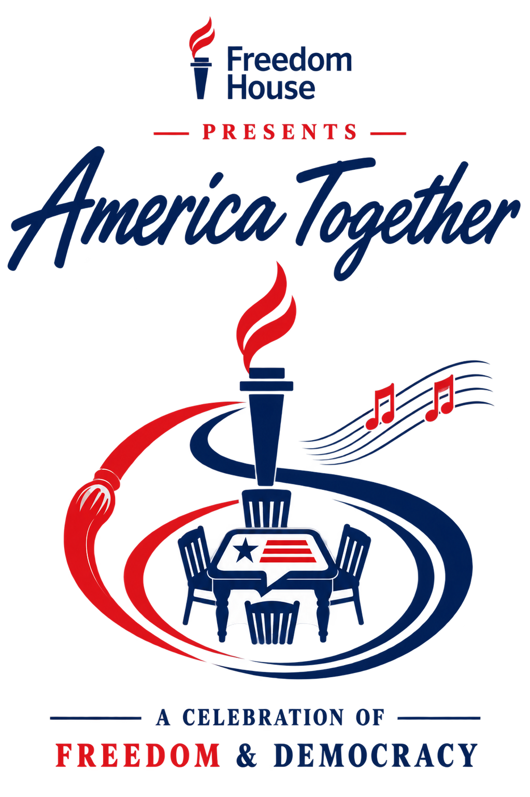

America Together Dallas
Sponsor Prospects for Freedom House
BRAD HILLINGER | SEPTEMBER 19, 2026 | FOR PROSPECT REVIEW

Purpose and recommended first approaches
We are seeking Freedom House’s approval to develop the first corporate funding conversations for America Together in Dallas. This package preserves our original ten prospects and adds ten Texas based companies. The aim is to build new support for Freedom House through art, music, food and civil conversation.
These are researched prospects, not commitments or evidence of interest in America Together. Proposed roles are our recommendations. Dallas is the pilot event; no participation in other cities is assumed.

Start with the presenting sponsor
We recommend reviewing AT&T, Toyota, Bank of America and American Airlines first for the $600,000 presenting position. Pursue one lead sponsor, with an agreed initial payment to support development and deposits. Freedom House’s relationships and donor priorities should determine the approach sequence.

The funding framework
Category | Positions | Each | Target
Presenting Sponsor | 1 | $600,000 | $600,000
Freedom and Democracy | 2 | $400,000 | $800,000
Arts and Culture | 1 | $400,000 | $400,000
Civic Dialogue | 2 | $400,000 | $800,000
Music and Performance | 3 | $400,000 | $1,200,000
The American Table | 2 | $300,000 | $600,000
Major Donor and Contributed Support | Various | By agreement | $400,000+
Total |  |  | $4,800,000+
These are fundraising targets, not quoted production costs. Track cash separately from donated goods and services. In-kind support helps only when it replaces a required, budgeted expense; it cannot pay unrelated invoices. Final costs require vendor and talent quotes.

Original ten prospects

1 AT&T
Texas connection: Dallas and North Texas. Its Dallas Discovery District combines art, food, entertainment and public gathering.
Proposed approach: Presenting Sponsor, or Music and Performance. Explore cash support with approved recognition on posters, the invitation page and event signage.
AT&T Discovery District

2 Bank of America
National company with a Dallas market. Its arts program supports museums and performing arts organizations.
Proposed approach: Presenting Sponsor, or Arts and Culture. Connect the request to public access to the exhibitions and a defined sponsor hospitality allocation.
Bank of America arts partnerships

3 Toyota
Texas connection: North American headquarters in Plano. Toyota has a substantial local corporate presence and documented music sponsorship activity.
Proposed approach: Presenting Sponsor, or Music and Performance. Offer a defined Dallas experience with employee participation and recognition, subject to available rights.
Toyota North American headquarters

Original ten prospects continued

4 American Airlines
Texas headquarters: Fort Worth. Its 2026 America250 sponsorship provides a relevant precedent for a national civic celebration. America250 is a separate initiative.
Proposed approach: Presenting Sponsor or Freedom and Democracy, with travel support negotiated separately. Establish the cash component before crediting donated flights.
American Airlines America250 announcement

5 American Express
National brand with a relevant audience. Its customer experiences include music, dining and entertainment.
Proposed approach: Music and Performance or The American Table. Explore hospitality and cardmember access within a clearly priced cash sponsorship.
American Express experiences

6 H-E-B and Central Market
Texas connection: H-E-B is based in San Antonio. H-E-B’s published giving categories include arts and humanities; Central Market offers a direct culinary connection.
Proposed approach: The American Table. Seek cash underwriting first, then separately price food, chef or promotional support. Confirm application eligibility and timing.
H-E-B giving guidelines

Original ten prospects continued

7 Microsoft
National technology and mission prospect. Microsoft describes work supporting democratic institutions and trusted technology.
Proposed approach: Freedom and Democracy or Civic Dialogue. Explore mission education and public participation; do not assume a general event sponsorship meets its funding priorities.
Microsoft Tech for Society

8 JPMorganChase
National company with a substantial Dallas presence. Its Dallas community work includes local investment and economic opportunity.
Proposed approach: Civic Dialogue or Presenting Sponsor as an alternate. Lead with the Dallas community benefit and an approved employee participation opportunity.
JPMorganChase in Dallas

9 Marriott Bonvoy
National hospitality brand and local hotel opportunity. Marriott Bonvoy Moments offers culinary, entertainment and other experiences.
Proposed approach: Hospitality support or The American Table. Separate a corporate cash request from room rates or donated stays negotiated with participating hotel owners.
Marriott Bonvoy Moments

10 Capital One
National brand with an entertainment platform. Capital One Entertainment offers access to music and other ticketed experiences.
Proposed approach: Music and Performance. Explore a cash sponsorship with defined guest access. Confirm any ticketing or payment category requirements before offering exclusivity.
Capital One Entertainment

Ten additional Texas prospects

11 Southwest Airlines
Texas headquarters: Dallas. Southwest’s community programs and its 2026 San Diego Symphony sponsorship show a connection to community access and music.
Proposed approach: Music and Performance, or travel support. Treat Southwest and American as alternate airline candidates until category rights are settled.
Southwest music sponsorship announcement

12 Dell Technologies
Texas headquarters: Round Rock. Dell maintains a sponsorship program that includes the Round Rock Express and technology relationships.
Proposed approach: Freedom and Democracy or a technology contribution. Lead with audience participation and the Dallas experience; keep equipment value separate from cash.
Dell sponsorships

13 Frost Bank
Texas headquarters: San Antonio. Frost supports nonprofit sponsorships and arts and culture. Its published policy places resource decisions with local leadership.
Proposed approach: Arts and Culture or Civic Dialogue. Begin through Dallas regional leadership and confirm a suitable request size before presenting a full category ask.
Frost community service and philanthropy

Ten additional Texas prospects continued

14 Charles Schwab
Texas headquarters: Westlake. Schwab describes its Texas commitment and employee involvement with community organizations.
Proposed approach: Civic Dialogue or The American Table. Explore a cash sponsorship built around local participation and client hospitality, without implying charitable eligibility.
Schwab Texas commitment

15 Omni Hotels and Resorts
Texas corporate office: Dallas. Omni operates Dallas hotels with meeting, dining and hospitality offerings.
Proposed approach: The American Table or host hotel support. Explore cash, rooms and event services as separate items. Confirm venue capacity and commercial terms with the property.
Omni corporate profile

16 Hines
Texas headquarters: Houston. Hines’ sustainability reporting describes community spaces and rotating exhibitions featuring Houston artists.
Proposed approach: Arts and Culture. Explore exhibition underwriting and suitable property space for approved poster or kitchen table installations. Property permission is separate from funding.
Hines sustainability report

Ten additional Texas prospects continued

17 CBRE
Texas headquarters: Dallas. CBRE’s community impact initiative has included Dallas among its supported markets.
Proposed approach: Civic Dialogue or Arts and Culture. Explore cash sponsorship and introductions to property owners for public installations. Do not count introductions as contributed dollars.
CBRE community impact initiative

18 Sysco
Texas headquarters: Houston. Sysco’s foodservice business and published community work provide a practical connection to food and gathering.
Proposed approach: The American Table. Explore cash underwriting alongside a separately quoted foodservice contribution coordinated with the contracted caterer and venue.
Sysco purpose and community support

19 USAA
Texas headquarters: San Antonio. USAA’s community responsibility work emphasizes military families, including economic mobility and mental health.
Proposed approach: Conditional prospect for Freedom and Democracy. A credible service member or veteran participation benefit would be needed; patriotic language alone is not a funding fit.
USAA corporate responsibility

20 Brinker International
Texas headquarters: Dallas. The owner of Chili’s and Maggiano’s describes community giving and a relationship with the North Texas Food Bank.
Proposed approach: The American Table. Explore a brand sponsorship through marketing, with food or hospitality support priced separately. Existing charitable priorities may limit a grant request.
Brinker community relationships

Freedom House review and next steps
We ask Freedom House to review these names, identify existing relationships and authorize a coordinated first round of approaches. A warm introduction and clear ownership may be more valuable than a company’s position on this list.

Agree the first round
Review the four presenting candidates first. In parallel, consider Bank of America for arts, H-E-B and Central Market for The American Table, Microsoft for mission alignment and Frost for local sponsorship. Assign each company one primary proposal and one relationship owner to avoid competing requests.

Record a decision for each prospect
For every company, record: existing Freedom House relationship; approved, hold or decline; introducing person; outreach owner; proposed role and cash ask; separate in-kind offer; next action and date. No prospect should be treated as cleared solely because it appears here.

Build a specific offer
The invitation should lead to a tailored proposal showing what the sponsor makes possible. Possible benefits include approved poster recognition, event signage, a sponsor listing on the QR destination page, guest places and tasteful table or chair recognition. Confirm the available inventory and cost before promising it.

Protect the funding plan
The seventy companies in this combined document are a prospect pool for eleven named sponsorship positions and additional contributed support. They are not seventy assumed sales. Competing airlines, banks, hotels and card brands are alternatives until category rights are negotiated. No exclusive rights, confirmed headliners, broadcast exposure or guaranteed press coverage should be promised.

Move forward after approval
Once Freedom House approves outreach and use of its name, begin introductions, confirm interest and budget timing, then issue individual proposals. Continue vendor and talent quotes in parallel so sponsorship commitments are matched to a costed production plan and realistic payment schedule.

Review notes
Freedom House contact: _______________________________________
First prospects cleared: ________________________________________
Existing relationships or holds: __________________________________
Agreed next review date: _______________________________________
Research checked September 19, 2026. Linked sources support the public facts in each profile. Suggested sponsorship roles and priorities are recommendations; availability, interest and funding eligibility remain to be confirmed.

Additional prospects by category
The first twenty profiles establish our initial prospect list. The following fifty companies broaden that list, grouped by suggested sponsorship category. All remain subject to the Freedom House review and outreach process described above.
Company names link to official information. These are proposed approaches, not confirmed commitments. Cash and contributed support will be tracked separately. Any continuation after Dallas would require a separate agreement within the eight city plan.

Presenting Sponsor
Company | Suggested approach
ExxonMobil | Explore leadership support for the complete Dallas celebration.
Energy Transfer | Approach around its Dallas connections and community investment.
Tesla | Explore an innovation theme and vehicle display. Exploratory prospect.
Caterpillar | Explore a major American industry presence with national potential.
Texas Capital | Position Dallas business leadership at the launch of the celebration.
Walmart | Explore broad community participation and national visibility.

Freedom and Democracy
Company | Suggested approach
Chevron | Connect its Texas presence with the celebration’s national purpose.
EOG Resources | Explore corporate underwriting of the celebration’s central purpose.
Cheniere Energy | Explore nationally visible sponsorship with a Texas starting point.
Hunt Oil Company | Explore Dallas leadership support for the pilot event.
SpaceX | Explore American achievement and shared curiosity. Exploratory prospect.
BNSF Railway | Explore the theme of connecting American communities.

Civic Dialogue
Company | Suggested approach
ConocoPhillips | Support civil conversation and community participation.
Occidental | Support conversations about shared community interests.
Kinder Morgan | Support community participation in the conversation program.
Vistra | Connect community investment with local participation.
Oncor | Support accessible Dallas community programming.
AECOM | Support conversations about the communities people want to build.
Jacobs | Connect community problem solving with civil discussion.

Major Donor and Contributed Support
Company | Suggested approach
Academy Sports + Outdoors | Explore community participation, equipment and event support.
Topgolf | Explore sponsor gatherings and donated hospitality experiences.
Dave & Buster’s | Explore hospitality, donated experiences and community promotion.
Costco | Explore food, supplies and practical event support.

Arts and Culture
Company | Suggested approach
Texas Instruments | Connect creativity, invention and public engagement.
Michaels | Support public art participation and exhibition activities.
Cinemark | Connect storytelling, visual art and audience development.
Kendra Scott | Explore creative programming and fundraising participation.
Delta Air Lines | Explore exhibition sponsorship and participant travel support.
United Airlines | Explore arts sponsorship with potential relevance across several cities.
Target | Connect creativity and design with public participation.
The Walt Disney Company | Explore American storytelling and creative experiences.
Comcast / NBCUniversal | Explore storytelling, promotion and community engagement.

Music and Performance
Company | Suggested approach
Valero | Offer prominent recognition around the major music evening.
PepsiCo / Frito-Lay | Explore music sponsorship with food and beverage participation.
Keurig Dr Pepper | Explore beverage recognition around the music evening.
7-Eleven | Explore consumer promotion and audience engagement.
Tito’s Handmade Vodka | Explore adult beverage sponsorship and charitable event support.
Raising Cane’s | Explore audience engagement and community event sponsorship.
Sony | Explore music sponsorship and recording equipment support.
American Honda | Explore consumer engagement around the music evening.

The American Table
Company | Suggested approach
Phillips 66 | Bring employees, community guests and business leaders together.
Enterprise Products | Underwrite a gathering of community and business leaders.
Halliburton | Offer employee, client and community hospitality.
Fluor | Gather business leaders, employees and community guests.
McKesson | Support community connection through a shared meal.
Coca-Cola Southwest Beverages | Connect beverage service with the shared dining experience.
YETI | Explore branded drinkware and a visible gathering experience.
Whole Foods Market | Connect food, community and the shared dining experience.
Whataburger | Bring a recognizable Texas food brand into community hospitality.
Hilton | Connect the dining experience with guest and talent hospitality.

